**Solution 1 b)** Numerical Dispersion Curves

For $β_{1}=0.39$:

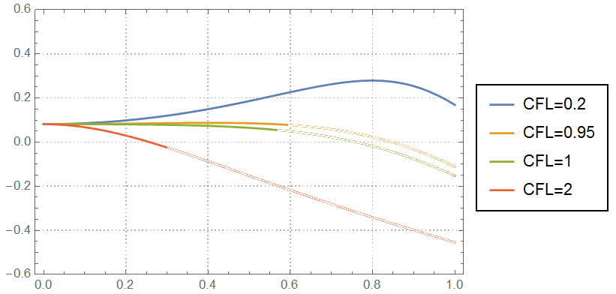

For $β_{1}=0.65$:

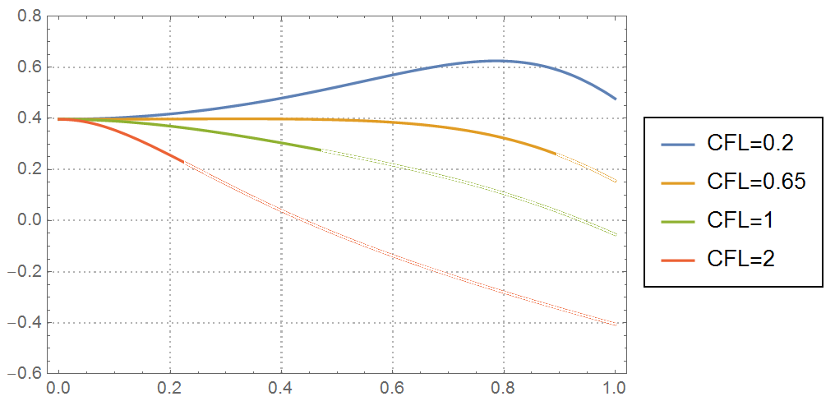

**Solution 1 c)** Values of $k∆x$ corresponding to $\frac{∆t}{T}≥0.3$

$\left(\frac{k∆x}{π},\frac{c-c_{0}}{c_{0}}\right)$ corresponding to $\frac{∆t}{T}≥0.3$ have been presented in the above plots as dulled curves.

**Solution 1 d)** Optimal CFL values

In case of $β_{1}=0.39$, wave modes for $k∆x<1$ have $\frac{c-c_{0}}{c_{0}}$ value of about 0.08 and the optimal CFL value is 0.95. Since the shortest wavelength is $2∆x$, wave nodes with $k∆x>1$ do exist. There is no CFL number for which all modes are non-dispersive. In case of $β_{1}=0.65$, the $\frac{c-c_{0}}{c_{0}}$ value is 0.40 and the optimal CFL value is 0.65. The discarded wave modes (i.e. the ones corresponding to $\frac{∆t}{T}≥0.3$) have been presented above as dulled curves.